Name : Dahlia Shehata Mahmoud

ID : 28

Lab Assignment 2: Threads

Problem Statement:

- It is required to implement multi-threaded matrix multiplication using 2 methods:
(1) a thread computes each row in the output matrix
(2)a thread computes each element in the output matrix.
- Compare the two implementations according to the following:
(1) the number of thread created
(2) the execution time taken.

Code Organization:

The code is divided between header files and C files.
There exists 3 main C files:

- file_processing.c: responsible for reading matrices from files and allocate memory for them in order to be stored and for writing the multiplication result in the output file.
- Rows_Threading.c: responsible to create array of threads of length equal to the number of the output matrix rows, calculate each threaded row using matrix multiplication and finally join the threads together in case of success else report error to the main function.
- Elements_Threading.c:responsible to create array of threads of length equal to the number of the output matrix elements (r1*c2), calculate each threaded element using matrix multiplication and finally join the threads together in case of success else report error to the main function.
- main.c: uses the 3 above files to read files ,store them , allocate memory for the output array,execute the 2 matrix multiplication methods and calculate the time stamp taken by each one (in seconds and microseconds) as well as the number of thread used .

Main Functions:

Function Name | Responsible for
void elementMultiplication  (void* thread_id) | When the element is the current thread ,this function computes the multiplication value for each element
int threadedElements() | Creates array of threads of size number of elements in the output array and calculate each element and then join threads
void rowMultiplication (void*thread_id) | When the row is the current thread ,  this function computes the multiplication value for each row
int threadedRows () | Creates array of threads of size number of rows in the output array and calculate each row and then join threads
long long**readFile  (char* fileName,int file_id) | Read the specified input file or “a.txt/b.txt” and store matrices in memory
bool writeToFile(char*fileName) | Write the output array in file
void setup() | Set the defaults values for files
char* modifyFileName  (char* fileName,char*extension) | Generates the the 2 output filenames from the name specified by user
bool checkExtension  (char*fileName) | Handles “.txt”extension for formatting purposes
void displayData  (struct timeval start, struct timeval stop,int threads,int id); | Display data in console :  number of threads used and tome taken by each method

How to compile and run code:

- in the terminal reach the directory of the project using “cd”
- type “make” to generate “matmult.out”
- in the terminal type ./matmult to multiply matrices in “a.txt” and “b.txt” and get the output in “c_1.txt”and “c_2.txt”
- n the terminal type ./matmult Mat1 Mat2 MatOut to multiply matrices in “Mat1” and “Mat2” and get the output in “MatOut_1.txt”and “MatOut_2.txt”.

Sample runs:

Input file 1 | Input File 2 | Output file 1 | Output File 2
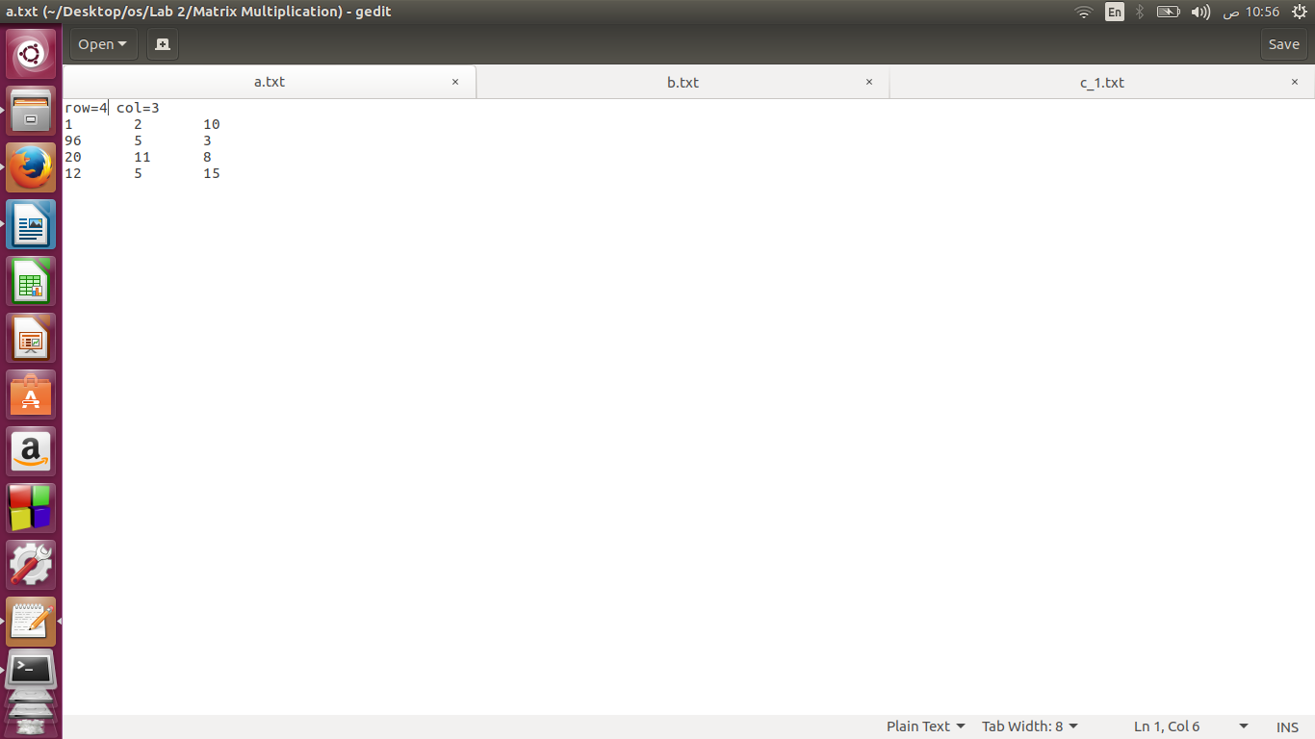  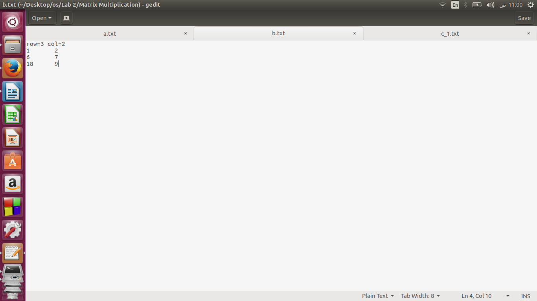  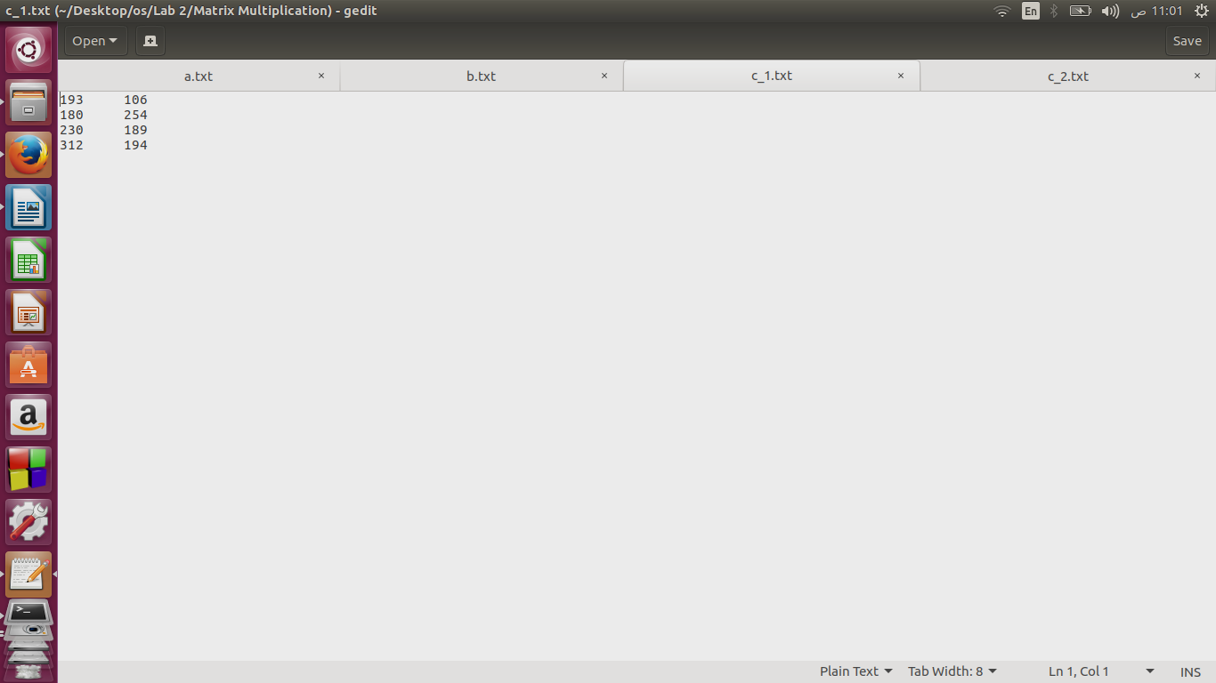  a.txt | b.txt | C_1.txt | C_2.txt
Console
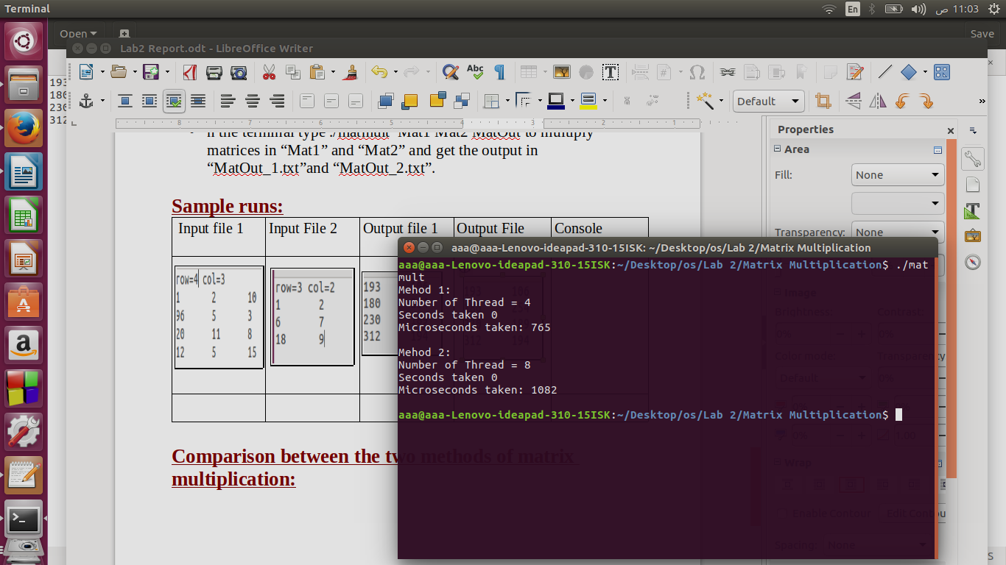

Input file 1 | Input File 2 | Output file 1 | Output File 2
Mat1  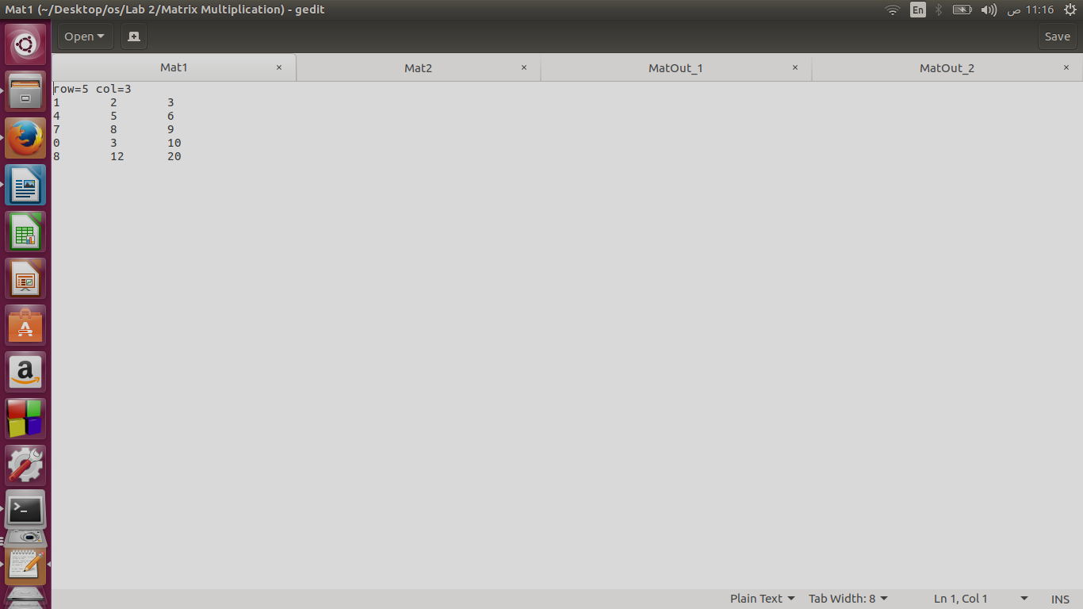 | Mat2  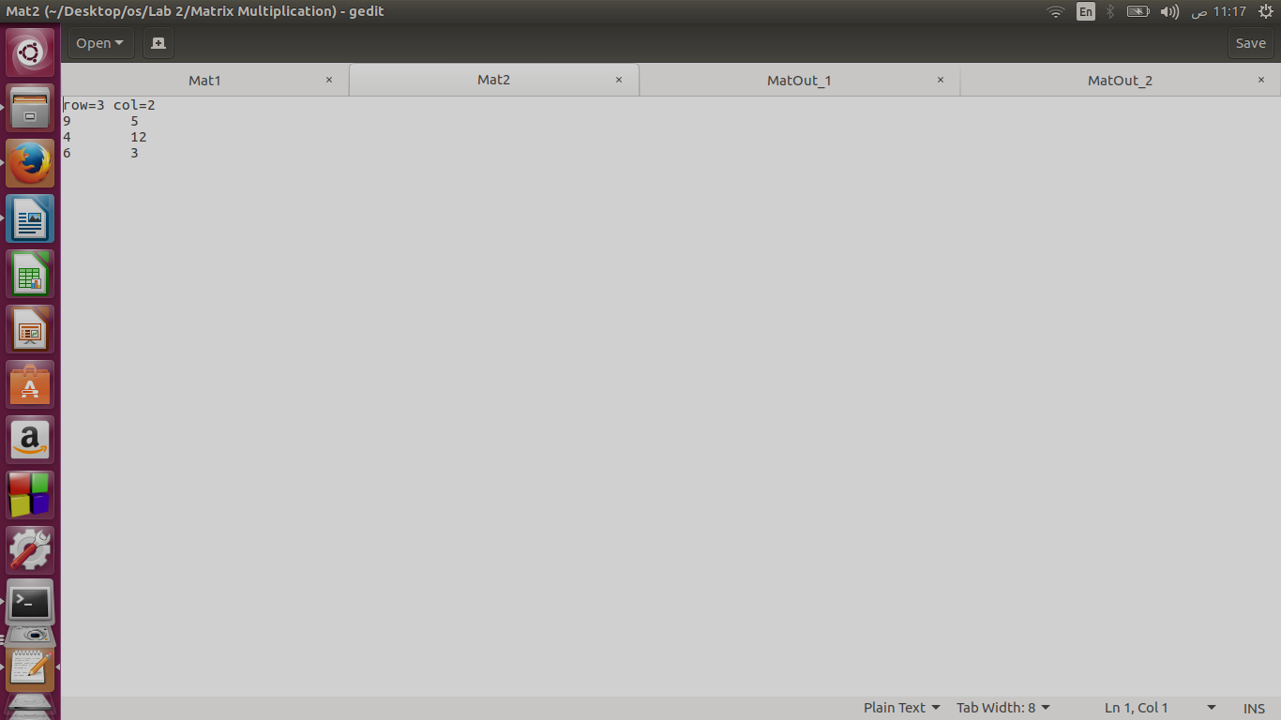 | MatOut_1  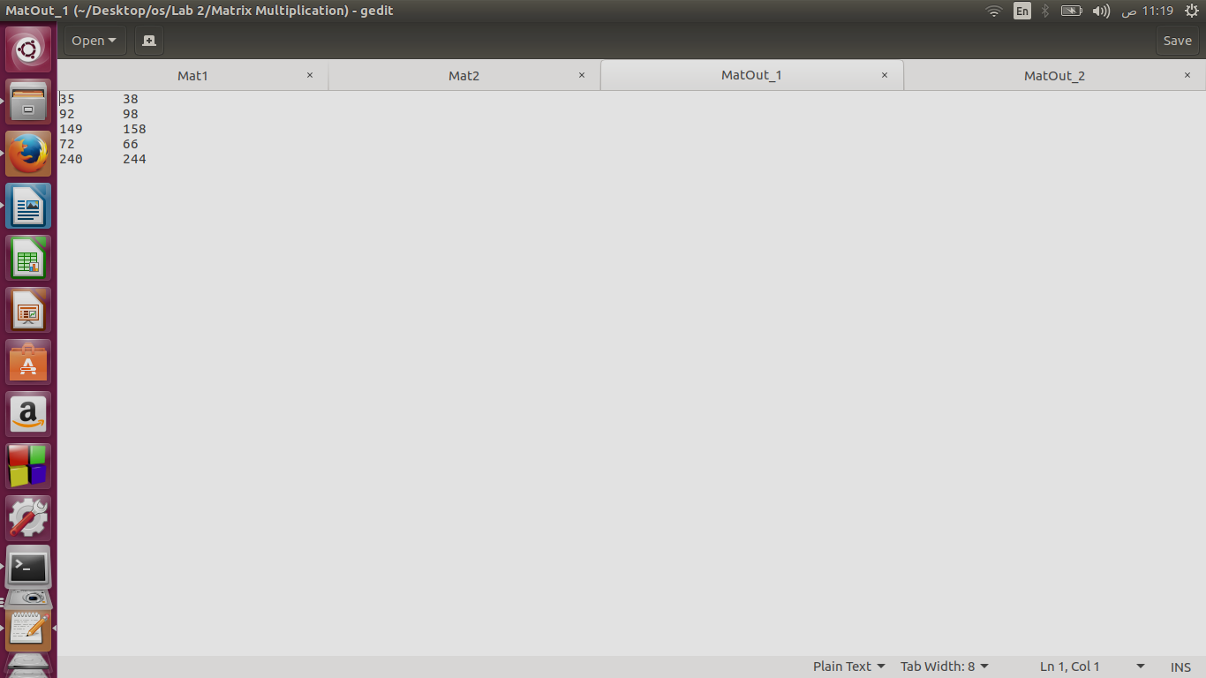 | MatOut_2
Console
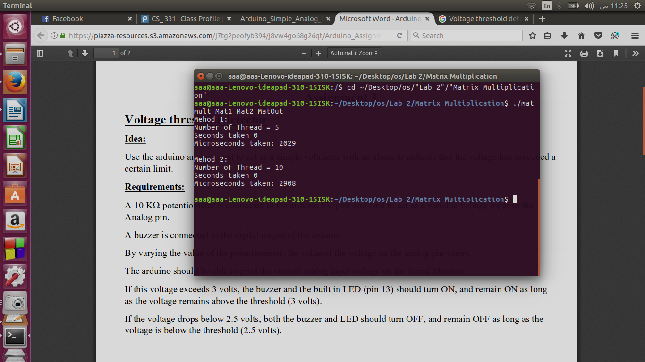

Change directory to the the one containing project

a.txt:

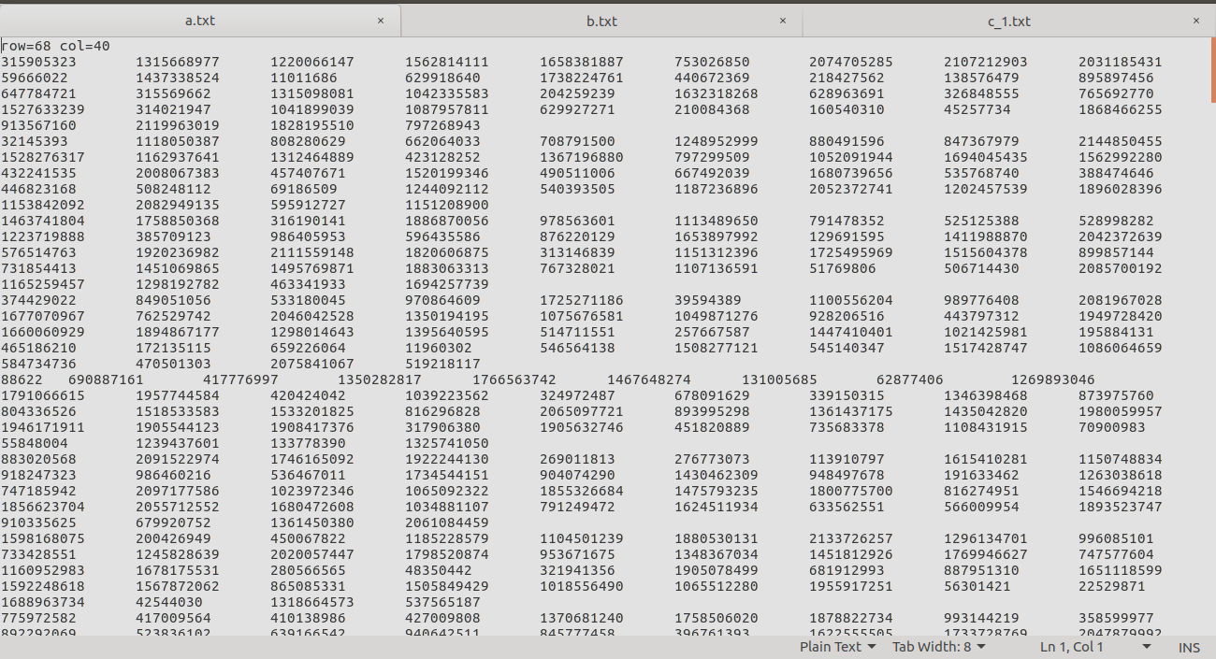
b.txt:
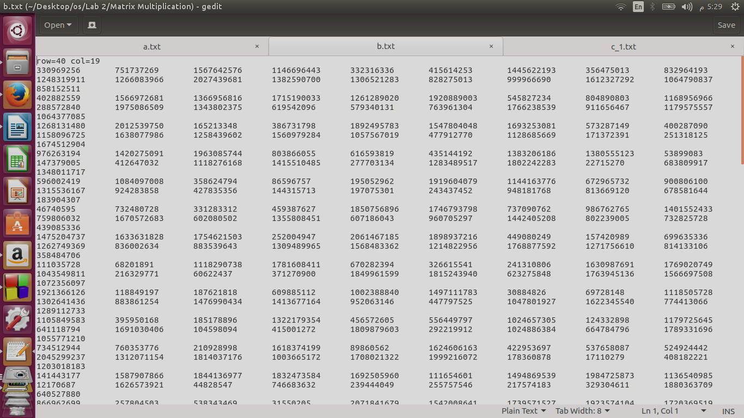

c_1.txt:
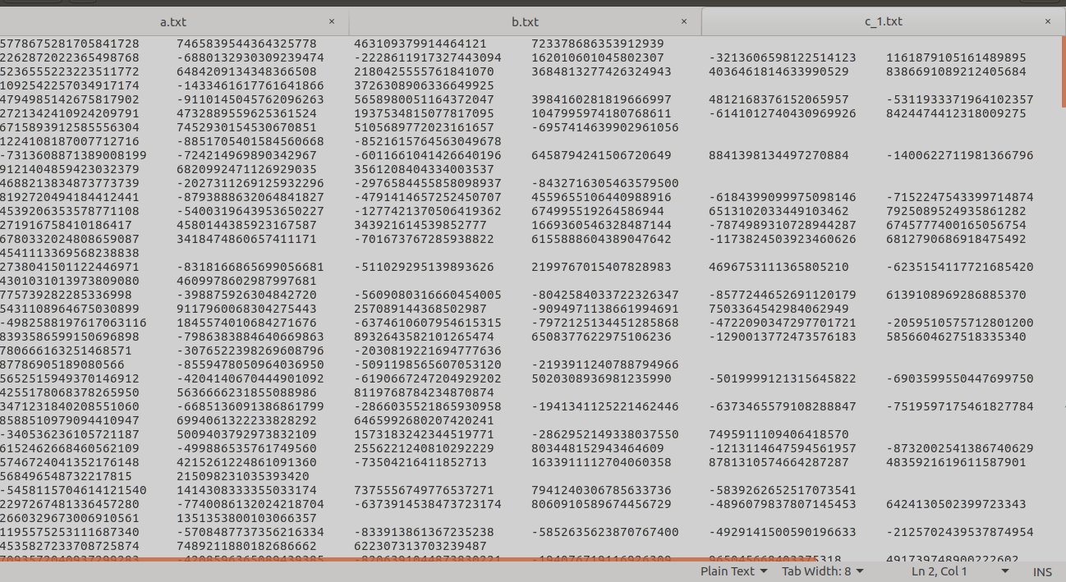
Console:

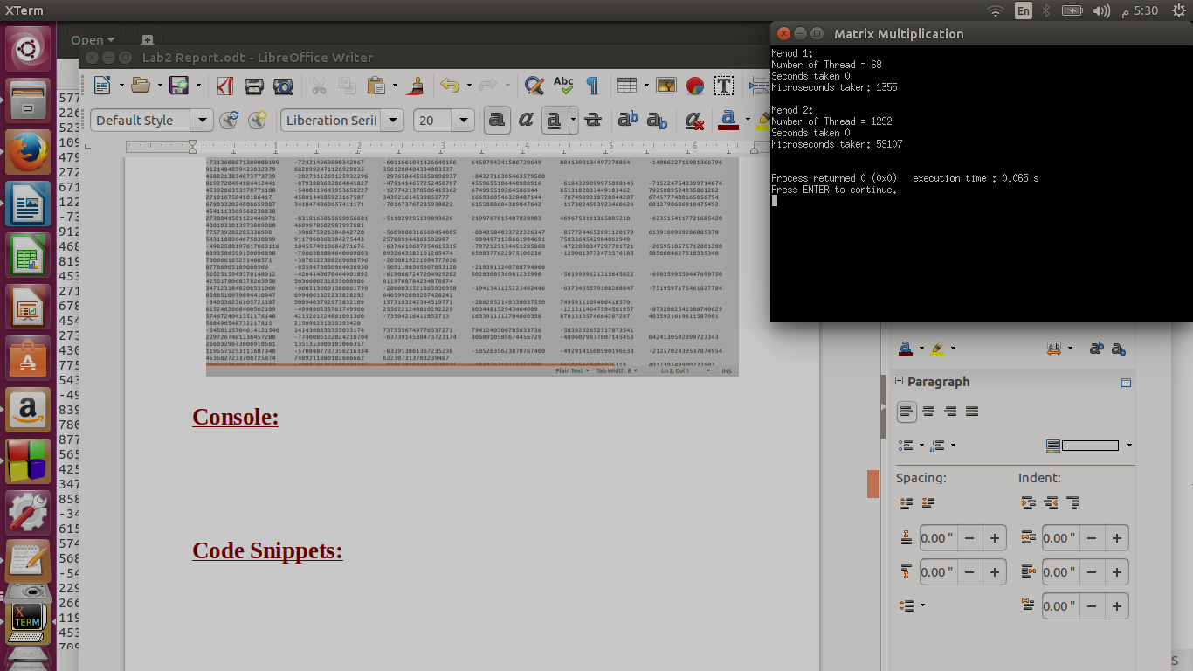

Code Snippets:
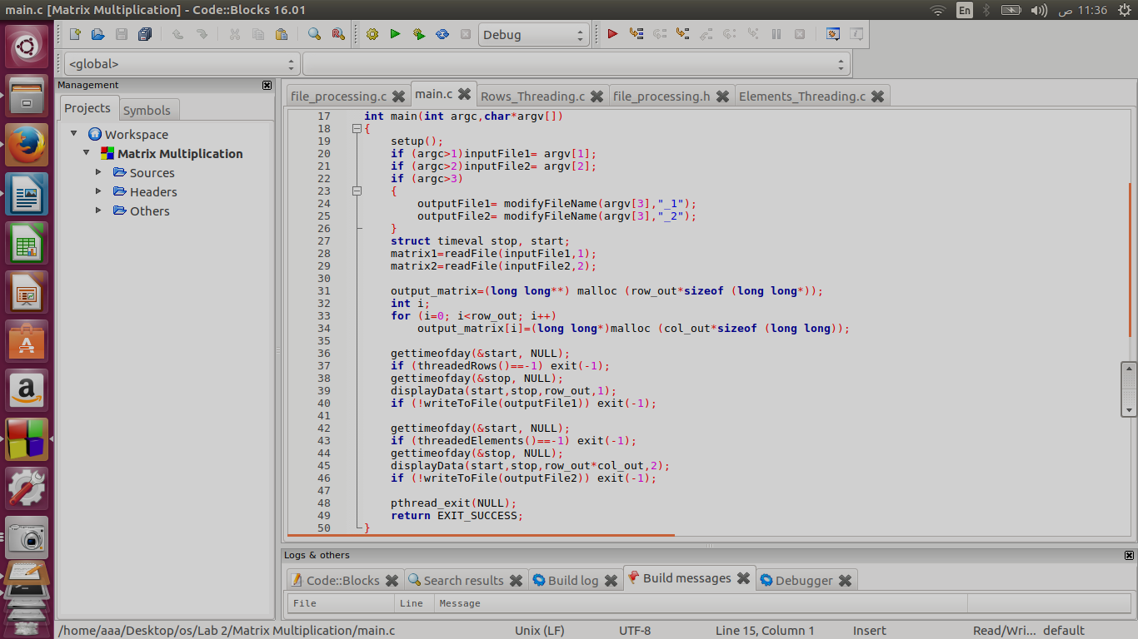
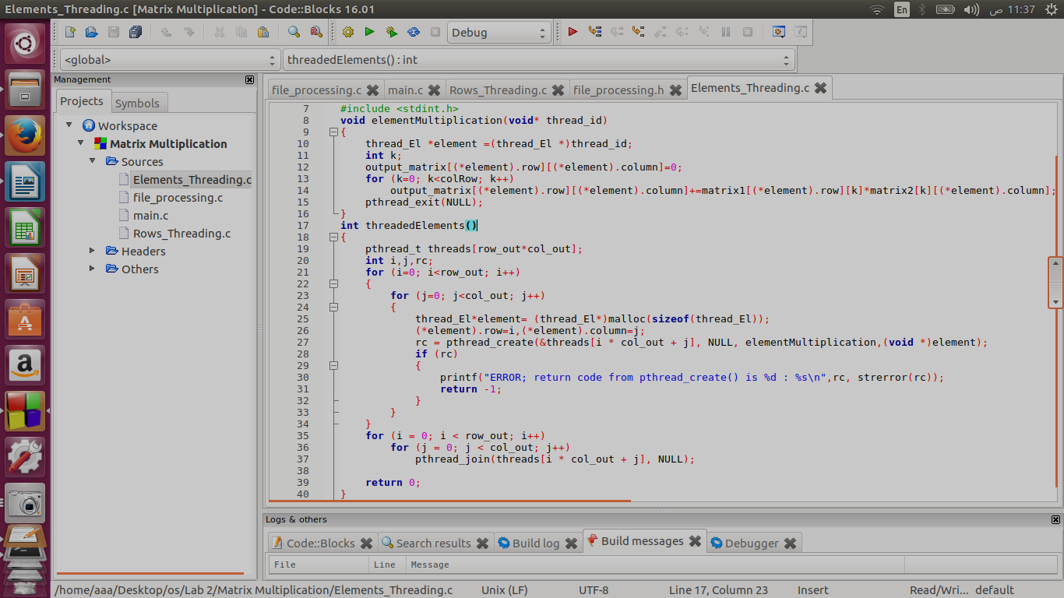

Comparison between the two methods of matrix multiplication:
- Relation between size of different samples and time per microseconds:

- According to graph :The second Method is slower

- Relation between size of different samples and number of threads:

- According to graph : the second Method uses larger number of threads

In conclusion :
Number of threads is proportional with time in microseconds. The more threads we use,the more time we take and the slower the multiplication is.

Method 1 | Method 2
faster | slower
Number of threads is less  Number of threads= number of rows in the output matrix | Number of the threads is larger  Number of threads= number of elements in the output matrix

